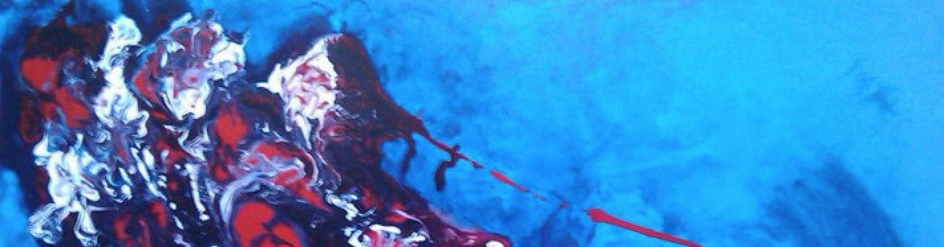 | IVÁN SOTO HERNÁNDEZ  Tel. 865-317-1012  865-212-3977  E-mail: yoto1983@hotmail.com
International Group Exhibitions | 2017  - Exposición en sala de cabildo, Palacio Municipal de Guadalajara, Guadalajara, Jalisco, Mexico.  - “Arte para la integración”, San Javier Club (private club)- Guadalajara, Jalisco, Mexico.  2016  - “International Latino Art Exhibition”, Emporium Center/ Arts and Culture Alliance- Knoxville, Tennessee.  - Seres Oxidados Gallery Casa Hola Knoxville Tennessee U.S.A “ Individual “  - Voces Contemporaneas Nashville Public Library Nasville TN.  2015  - “Frutos Latinos”, Knoxville Museum of Art- Knoxville, Tennessee. First- place winner.  - “Arts of the Americas”, Joseph D. Carrier Gallery, Columbus Center – Toronto, Canada.  - “Riding through the Americas”, Joseph D. Carrier Gallery, Columbus Center Toronto, Canada.

2014
- Latin American Art Exhibition, Saint Brigid´s Centre for the Arts- Ottawa, Canada.
- “Honduras Artística al descubierto” – Ottawa, Canada.
- Talento Bilingüe de Houston- Houston, Texas. USA.
- Emporium Center Gallery- Knoxville, Tennessee. USA.
International Solo Exhibitions  Group Exhibitions | 2013  - Feathered Serpent Gallery – St. Petersburg, Florida. USA.  - “An encounter with Honduras”, Saint Brigid’s Centre for the Arts- Ottawa, Canada.  - Municipality of San Isidro – Perú.  - Mambo Restaurant – Ottawa, Canada.  2012  - Shendman Gallery – Ottawa, Canada  - Library and Archives Canada – Ottawa, Canada  - LaSalle College – Montreal, Canada  2011  - Plaza Hotel – San Salvador, El Salvador  2009  - Auction – American Cancer Association – Miami, FL, US  2010  “Romerías de Mayo”- Olguín, Cuba.  2012  - Antico Gallery – Tegucigalpa, Honduras.  - San Pedrano Cultural Center Biennial – Honduras.  - IHCI Central American Biennial – National Gallery – Honduras.  2011  - Asociación de Artistas Hondureños, Nova Center Mall – Tegucigalpa, Honduras.  - Asociación de Artistas Hondureños, Hispanic Culture Hall – Tegucigalpa, Honduras.  2010  - Pixtogra Group, Dimensions and shapes, Botichelli Gallery – Honduras.  - IHCI, Pixtogra Group, Suid Aurora Hotel, Honduras.  - Expo Sale in support of “Casa Renacer” and Agatha Victims, Tre Fratelli, Honduras.  2009  - Banco Centroamericano – Honduras.  - Pixtogra Group – Municipality of La Ceiba Atlántida, Honduras.  - Pixtogra Group – Champas Swindford - La Ceiba Atlántida, Honduras.  2008  - IHCI Biennial, Museo del Hombre Hondureño – Honduras.  - Pixtora Group, Grupo Feminista Mujeres Universitarias Headquarters – Honduras.  - IHCI’s Miniatures, Chiminike Interactive Learning Centre – Tegucigalpa, Honduras.  - IHCI Art Fair 2008 – Honduras.  - Baristo Gallery – Tegucigalpa, Honduras.  2007  - IHCI Biennial, Museo del Hombre Hondureño – Honduras.  2006  - Honduras Maya Hotel – Honduras.  - Plaza San Martin Hotel – Honduras.  - French Alliance – Honduras.
On Permanent Display | - Feathered Serpent Gallery- St. Petersburg, Florida. USA.  - Antico Gallery- Tegucigalpa, Honduras.  - Origenes Gallery-Tegucigalpa, Honduras.  - Lilia Faulkner’s Representative- Canada.
Education | Diploma in Plastic Arts  Escuela Nacional de Bellas Artes (National School of Fine Arts). Tegucigalpa, Honduras.

